Chapter 16, Problem 29.

Calculate i(t) for t > 0 in the circuit in Fig. 16.52.

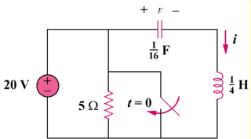
20u(–t) V

5 Ω

Figure 16.52
For Prob. 16.29.

Solution

Step 1. Calculate the initial conditions and then convert the above circuit into the s-domain. Then solve for I, perform a partial fraction expansion, and convert into the time domain. v(0) = 20 volts and i(0) = 0.

0.25s

I
+ −

20/s

16/s

[16/s]I + [20/s] + 0.25sI = 0.

Step 2. {[16/s]+0.25s}I = –20/s = {[s²+64]/(4s)}I or I = –80/[(s+j8)(s–j8)] or

I = [A/(s+j8)] + [B/(s–j8)] where A = –80/(–j16) = 5∠–90˚ and
B = –80/(j16) = 5∠90˚ thus,

i(t) = [5e^{–j8t–90˚}+5e^{j8t+90˚}]u(t) = 10cos(8t+90˚)u(t) amps.

